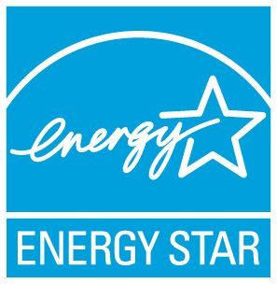

ENERGY STAR® Action Workbook for Congregations

Energy efficiency is the fastest, least expensive and largest single solution for simultaneously saving energy and money, and preventing greenhouse gas emissions. Through the market-based, voluntary ENERGY STAR program, the EPA is helping congregations save money and protect human health through superior energy efficiency in their worship facility. ENERGY STAR certified buildings and plants cost less to operate and help protect the environment. On average, these buildings use 35 percent less energy and cause 35 percent fewer greenhouse gas emissions than comparable buildings across the country. ENERGY STAR is helping congregations use low-cost, even no-cost actions, the time and talent of their members, and strategic investment to save money and prevent pollution.
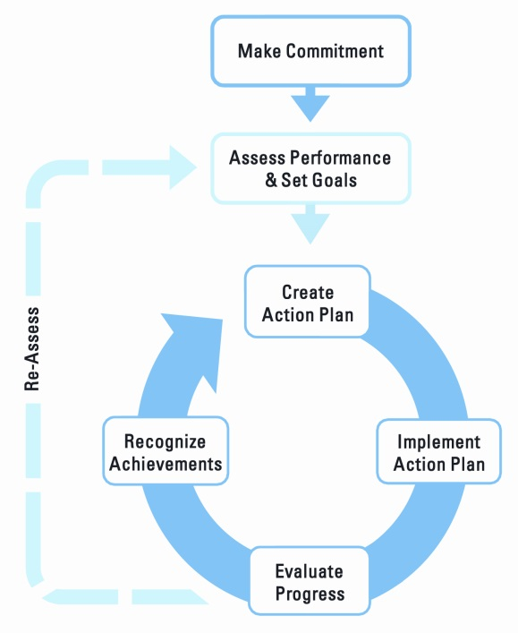
The following steps are a summary of the more detailed information and resources to be found in the ENERGY STAR Action Workbook for Congregations, supplemented by a detailed hb resource appendices. Both are free downloads in both English and Spanish at www.energystar.gov/Congregations
Step 1: Make a Commitment to Saving Energy
ENERGY STAR Guidelines for Energy Management
Become an ENERGY STAR partner and make a commitment to better stewardship at www.energystar.gov/JoinBuildings.
Gain the support of your clergy, staff and governing board. They are critical to successful efficiency projects.
Motivate your congregation. Your congregation members are the primary source of finance, as well labor for many energy efficiency projects. Help your members understand the projects.
Create a stewardship team. This “green team” can be large or small—or even a committed individual. Invite youth to contribute.
Step 2: Assess Performance
Benchmark your building’s energy performance using EPA’s free, online Portfolio Manager® tool. Portfolio Manager will also help you set energy efficiency goals, and document achievements. Learn more at www.energystar.gov/Benchmark.
Step 3: Set Goals
Evaluate priorities and set goals. Work with key decision makers and evaluate how well the project aligns with your congregational priorities.
Prioritize your goals. Evaluate potential costs and benefits for action.
Step 4: Create an Action Plan
The Portfolio Manager tool, used in coordination with the ENERGY STAR Action Workbook for Congregations, and additional resources available at www.energystar.gov/Congregations can help you:
Walk through your building. Identify which low-cost, no-cost ENERGY STAR Sure Energy Savers can be quickly implemented in your building.
Find ENERGY STAR training and informational webinars at www.energystar.gov/buildings/training.
Find ENERGY STAR qualified products, purchasing specifications, and calculators at www.energystar.gov/Products.
Determine technical issues, solutions, steps, and targets and take stock of your available resources.
Determine if projects require funding and how best to secure it. Worthwhile projects may or may not require funding. Some projects may be attractive to targeted donations. Savings from low or no-cost actions may fund some projects, while others may require capital investment for larger savings.
Step 5: Implement the Action Plan
This is the time to hire a contractor if necessary; to negotiate based on competing bids, and name a congregation member or team to manage the projects.
Organize a “Treasure Hunt” with resources online at https://www.energystar.gov/treasure_hunt
Create a communication plan to build awareness, educate, and motivate your members.
Step 6: Evaluate Progress
Measure and verify your savings. Portfolio Manager will calculate the effect of your projects on your energy consumption, “normalizing” your savings for weather variations, and help you plan continuing improvement.
Report progress to your congregation. Generate a Portfolio Manager “statement of energy performance,” employing easy-to-use report templates, or create the custom reports you want. Easily share data.
Step 7: Recognize Achievements
Provide recognition at regular intervals for everyone who helped the project succeed.
Tell your story. Share your success with other congregations and in your community through traditional and social media. Get your youth groups “tweeting” to recognize your accomplishments and inspire others.
People enjoy friendly competition that supports a good cause and inspires excellence. For the ENERGY STAR Guide to Energy Efficiency Competitions, see www.energystar.gov/CompetitionGuide.
Apply for the ENERGY STAR - recognized by more than 90% of Americans as the mark of excellence in energy efficiency, environmental, and financial stewardship. Learn about eligibility at www.energystar.gov/BuildingCertification and look for a Licensed Professional providing free data verification at www.energystar.gov/buildings/lp_finder

